
HASS  People and the environment |  | Year 5 |  |  | Unit 1
Assessment task — People and the environment: Model response
Name |  |  | Class
Teacher |  |  | Date
Task
Purpose of assessment: To investigate the characteristics of places and use evidence to draw conclusions about a preferred place to live.
Instructions
Part A: Human and environmental characteristics of places
Students will:
- identify and describe the locations of places using mapping conventions
- sort, record and interpret data and information about the characteristics of places.
Part B: Influences of people and the environment on places
Students will:
- identify and explain interconnections between people and the human and environmental characteristics of places and between components of the environment.
Part C: Decide on a place to live
Students will:
- evaluate the characteristics of places to decide the country in which they would prefer to live.
Part A: Human and environmental characteristics of places
Use Source 1 to complete Q1–5.
- Colour and label Sweden and Mexico on the map.
- Add a border and title.
- Label the major lines of latitude.
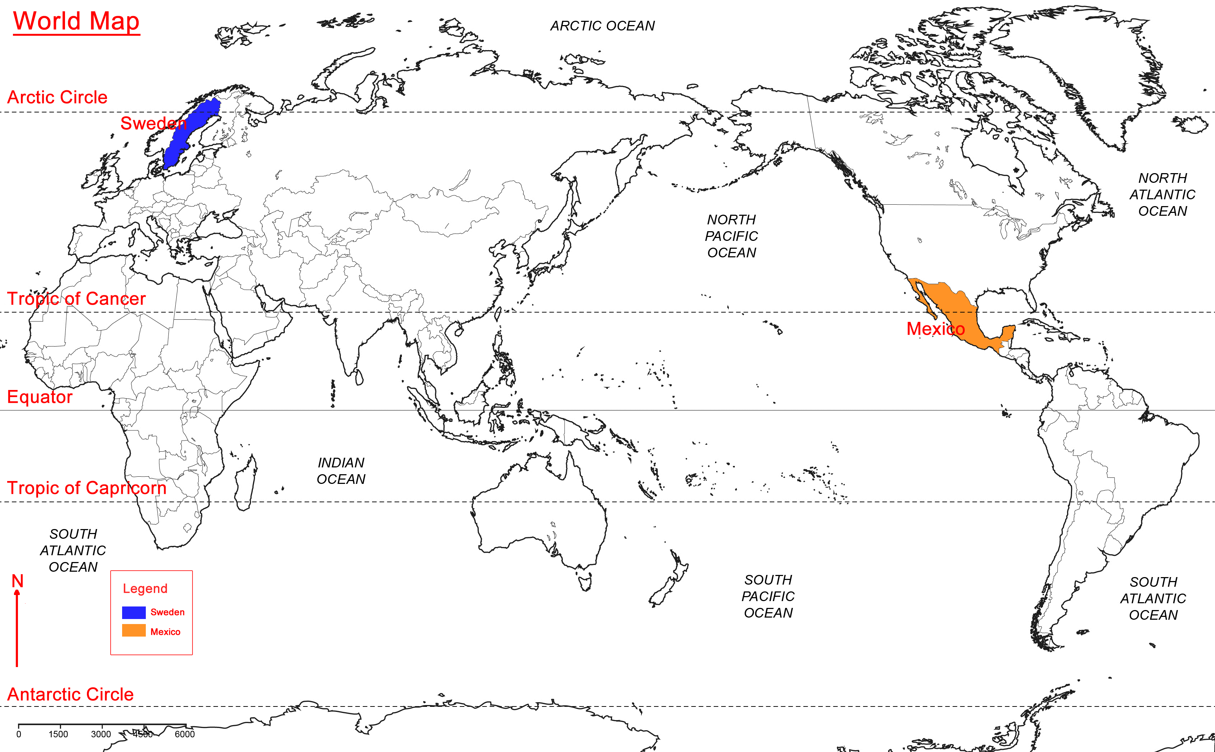
- Which body of water is located west of Sweden?
North Atlantic Ocean
- Identify and add a mapping convention missing from this map.
Students should identify and add a either a north point or legend.
Use Sources 2 and 3 to complete Q6‒10.
- Use sources to fill in the missing temperature data in the table below.
Temperature (°c) | Jan | Feb | Mar | Apr | May | Jun | July | Aug | Sep | Oct | Nov | Dec
Mexico City | 13 | 15 | 17 | 18 | 19 | 19 | 18 | 18 | 17 | 17 | 15 | 14
Stockholm | –2 | –3 | 0 | 4 | 10 | 15 | 17 | 16 | 11 | 6 | 1 | –2
- Write a comparative statement that draws from the data in the table above.
Answers will vary.
Mexico City experiences warmer temperatures than Stockholm all year round. The average temperature for both Sweden and Mexico increases between the months of March through June.
- Write true or false for the following statements. Use sources.
It gets warmer in Stockholm between February and July. | True
Mexico City receives less precipitation between March and July. | False
Both Mexico and Sweden experience summer during the middle of the year. | True
Stockholm receives more precipitation during its winter months. | False
- Describe how population density in Sweden is distributed — consider the terms clustered and linear. Answers will vary.
The highest population density in Sweden is clustered around Stockholm. The lowest population density is shown as a linear distribution which extends from central to northern Sweden.
- Why do you think some areas of Mexico are more densely populated? Answers will vary.
Some areas of Mexico are more densely populated because many people live in or near major cities, such as Mexico City.
Part B: Influences of people and the environment on places
- Circle the environmental characteristics.
Mexico’s landscape is desert-like in parts.
The Baltic Sea is located off Sweden’s coastline.
Herring is a fish commonly prepared for meals.
Snow falls and lakes freeze over during cold winter months in Sweden.
Housing is tightly built into hillsides in Mexico City.
Ice hockey is a favourite sport in Sweden.
Mexico City has a
warm temperate climate with low rainfall.
Houses in Sweden are wooden and they have steeply pitched roofs.
Mexico City is surrounded by mountains and volcanos.
Mexico City is
densely populated.
Soccer is one of Mexico’s most popular sports.
Mexico City is the
capital of Mexico.
- Match characteristics from above that are interconnected. For example:
The Baltic Sea is located off Sweden’s coastline.
Herring is a fish commonly prepared for meals.
Housing is tightly built into hillsides in Mexico City.
Mexico City is surrounded by mountains and volcanos.
Houses in Sweden are wooden and they have steeply pitched roofs.
Snow falls and lakes
freeze over during cold winter months in Sweden.
- Explain the interconnections identified above.
For example: The Baltic Sea forms Sweden’s coastline which means the fishing industry is strong and herring is a cost effective and readily available food source for people in Sweden.
Urban development in Mexico City has been influenced by the surrounding mountains and volcanoes. As a result, outward growth has been limited, and there are areas of high density housing.
Sweden experiences freezing temperatures during winter which causes snowy and icy conditions. People build houses with steeply pitched roofs to prevent snow from piling up. Snow covers the roof, but large amounts are able to fall off.
Part C: Decide on a place to live
- Comment on the characteristics identified for each country.
- Tick if the characteristic would positively influence your decision to live in that country.
Mexico
Environmental characteristics
global location | For example: Mexico is located near the South American continent and has easy access to South American countries.
climate | Mexico has diverse climate regions. Mexico City has a warm, temperate climate. Average temps range from 12 to 16°C — it rarely gets very cold.
major landforms | Mexico has large mountain ranges (Sierra Madre Oriental, Sierra Madre Occidental) and volcanos. There are sandy beaches in tropical coastal parts of Mexico.
major cities | Mexico City is the capital of Mexico. It is not close to any oceans. Mexico City has a lot of air pollution.
other | Mexico is a part of the North American continent. There are many interesting species of native animals in Mexico, such as the jaguar.
Human characteristics
languages spoken | In Mexico, most people speak Spanish. Native languages are also spoken. English is the most widely used foreign language.
clothing | A traditional shawl worn mostly by men is the brightly-coloured serape. It is worn in cooler climates. Most people wear western-style clothing suited to the climate.
food | Traditional foods in Mexico include spicy sauces, different types of meat and fresh vegetables. Chili is a widely used ingredient.
other | The ruins (such as temples and pyramids) of ancient civilisations, such as the Maya and Aztec civilisations, can still be seen in Mexico today.

Sweden
Environmental characteristics
global location | Sweden is located near Finland and Norway in Europe. It has easy access to many other north-eastern European countries. It is located in the northern hemisphere.
climate | Sweden is located in the continental climate region. The country experiences warm summers and cold to very cold winters. It snows in many parts of Sweden during the winter months.
major landforms | Many islands can be found along the coastal regions of Sweden. There are mountains, hills and valleys in Sweden. There are also lots of inland lakes.
major cities | Stockholm is the capital city of Sweden. The highest population density in Sweden is clustered around Stockholm.
other | Alpine tundra areas are located in north-eastern Sweden. No trees grow in this region because of the high altitude. The snow-capped mountain tops of Sweden’s Tarfala Valley are very picturesque.
Human characteristics
languages spoken | The official language is Swedish. However, most people in Sweden speak English because they study it at school.
clothing | There is a special costume worn by some Swedes on special holidays. Most people wear western-style clothes that are suited to the climate.
food | Fish dishes such as pickled herring are popular because of Sweden’s fishing industry. Swedish meatballs is a well-known traditional dish.
other | Viking culture originated in Sweden and in other neighbouring countries. Many people are interesting in Viking history.
- In which country would you prefer to live?
Answers will vary.
Mexico
- Explain your decision. Include in your answer:
- how you made the decision and the evidence you considered
- the characteristics that were important to you
- a comparison of the characteristics of both countries.
Answers will vary.
I would like to live in Mexico because of its human and environmental characteristics. Parts of Mexico have a warm, temperate climate, like in Mexico City. This is important to me because I do not like very cold temperatures. Also, there are beautiful tropical beaches in parts of Mexico that I would like to visit for recreation. I would prefer to eat the spicy foods of Mexico; I do not like fish, so the seafood-based dishes of Sweden would not be preferred. Although Sweden has many beautiful landscapes, Mexico still has some rugged landscapes to explore. I am very interested in learning Spanish and studying the history of Mexico’s ancient civilisations. I would like to learn about the Vikings of Sweden, but I would especially enjoy learning about and seeing the ancient Aztec and Mayan ruins in Mexico. Overall, Mexico is my preferred place to live, mainly because of its warmer climate and interesting history.

